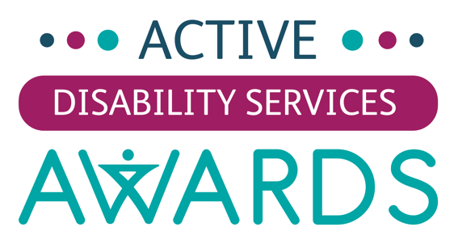

Entry Form

Details of Person, Programme or Disability Service being Nominated:

Name of Disability Service:

Name of Person or Programme being nominated:
Address:

Contact Phone No.:
Email:

Award Categories:

Please put an ‘X’ beside the appropriate category for this entry. Please note, if you are entering multiple categories a completed entry form will be required for each entry. A full description of the award categories can be found on our website www.caracentre.ie.

Best Physical Activity Programme
Best Outdoor Activity Programme
Best Health Education Programme
Best Community Engagement Programme
Active Service Management Team
Active Service Key Worker
Active Champion
Active Service Volunteer
Lifetime Service Award
People Make Places Award
Outstanding Community Disability Service
Outstanding National Disability Service Provider

Questions:

Please answer the following questions providing as much information as you can. Please provide insights, facts and figures to demonstrate the impact of your examples where possible. You should send photos (JPG’s) and PDF’s along with your entry form to support your entry for consideration by the judging panel.

Note: Remember that the judging of all entries will be carried out solely on the answers provided in this form along with the supporting files (Photos, PDFs) sent with it.

What we’re looking for are examples of the following:
- Increasing and sustaining physical activity and healthy lifestyles for service users through your programmes
- Achievements and milestones reached since January 2020
- How you have adapted your approach to providing physical activity and healthy lifestyles for service users throughout the pandemic
- Being creative and use of innovative practice
- The impact that programmes and work has had on service users
- Increase in the number of service users who have engaged in physical activity
- The wider impact on the service users (such as personal development, health and wellbeing and educational attainment)
- Other benefits that physical activity and healthy lifestyles have given service users (such as becoming healthier, strengthened mental health, enhance self-confidence, new motivation etc.)

-------------------------------------------------------------------------------------
Question 1:
Please describe how the person/programme/organisation includes physical activity for service users and details of how it is delivered?

Please type here:

-------------------------------------------------------------------------------------

Question 2:
Please describe how the person/programme/organisation has adapted and sustained physical activity for service users during the pandemic?

Please type here:

-------------------------------------------------------------------------------------

Question 3:
Please describe how the person/programme/organisation has a positive impact on the lives of service users through the delivery of physical activity?

Please type here:

-------------------------------------------------------------------------------------

Question 4:
Why you believe the person/programme/organisation deserves to win an Active Disability Service Award?

Please type here:

-------------------------------------------------------------------------------------

Details of Person submitting this Entry:

Name:

Disability Service:

Address:

Contact Phone No.:
Email:

Consent

Please place an ‘X’ in this box to confirm you have read, understood and agree to the terms and conditions related to these awards. You can read the terms and conditions at www.caracentre.ie/services-awards.

Submitting Your Entry Form:

Please send this completed form, along with supporting files in one email to the following email address:

rmccarroll@caracentre.ie

You should send photos (JPG’s) and PDF’s along with your entry form to support your entry for consideration by the judging panel. Please send along with the Entry Form in one email.



