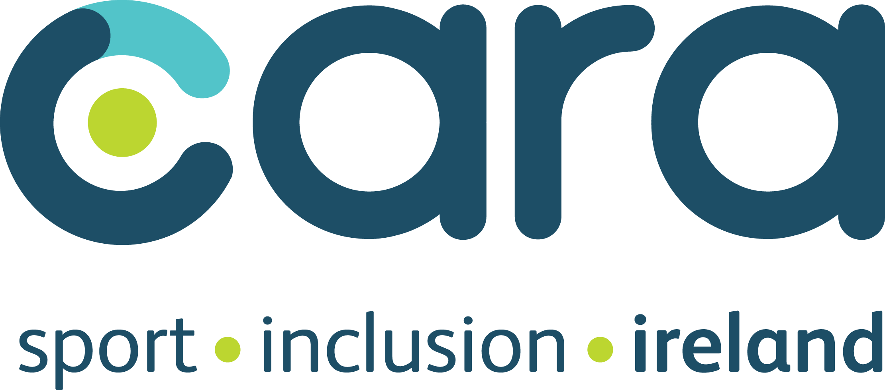
Local Sport Inclusion Disability Officers
For more information on the Sport Inclusion Disability programme please contact; Odhrán Doherty, Sport Inclusion Coordinator, Cara, Odoherty@caracentre.ie 0860212325.
Please see the contact details for your local officer below;
County | Name | Phone | E-mail
Carlow | Teresa O'Meara | 087-9025567 | tomeara@carlowcoco.ie
Cavan | Dean McElroy | 087-2623956 | dmcelroy@cavancoco.ie
Clare | James Murrihy | 087-9627696 065-6865434 | James@claresports.ie
Cork | Kate Feeney | 086-7947923 021-4347096 | kfeeney@corksports.ie
DLR | Brian O Donnell | 01-2719506 | bodonnell@DLRCOCO.IE
Donegal | Thérèse Laverty | 074-9116078 086-8349056 | sido@activedonegal.com
Dublin City | Nuala O'Donovan | 087-0666254 | nuala.odonovan@dublincity.ie
Dublin City | Lisa Kelly | 087-1147721 | lisa.kelly@dublincity.ie
Fingal | David Daly | 086-2401913 | DAVID.DALY@FCRS.IE
Kerry | Gearoid O’Doherty | 066-7183680 | Gearoid.odoherty@kerrycoco.ie
Kildare | Syl Merrins *LSP Coordinator |  | SMerrins@kildarecoco.ie
Kilkenny | Seamus Nugent | 087-3567884 | seamus@krsp.ie
Laois | Caitriona Slattery | 057-8671248 | cslattery@laoissports.ie
Limerick | Elaine Shea | 061-333600 | eshea@limericksports.ie
Longford | Orla Dempsey | 043-3343495 | odempsey@longfordcoco.ie
Mayo | Ray McNamara | 094-9047023 087-6973093 | rmcnamara@mayococo.ie
Meath | Terry Donegan | 046-9067337 | tdonegan@meathcoco.ie
Offaly | Jean Brady | 086-7912508 | jbrady@offalycoco.ie
Sligo | Shane Hayes | 071-9161511 | shane@sligosportandrecreation.ie
South Dublin | Lucy Cush | 01- 4149000 | lcush@sdublincoco.ie
Waterford | Pauline Casey | 086-7837385 051-849855 | pcasey@waterfordsportspartnership.ie
Wicklow | Clara Jenkinson | 0404-20100 | cjenkinson@wicklowcoco.ie
Wexford | Triona Shalloe | 053-9196367 | triona.shalloe@wexfordcoco.ie
Roscommon | Elaine Igoe | 090-6630853 | elaine@rosactive.org
Leitrim | Michelle Maguire | 071-9650498 | mfanning@leitrimcoco.ie
Tipperary | Aoife Dunphy | 087-1804191 | adunphy@tipperarysports.ie
Louth | Triona Faapito | 042-9324299 | triona.faapito@louthcoco.ie
Westmeath | Mary Duignan | 044-9338921 | mary.duignan@westmeathcoco.ie
Galway | Ellie Loftus |  | eloftus@galwaycoco.ie
Monaghan | Michelle Murphy *LSP Coordinator | 042-536459 | MMURPHY@MONAGHANCOCO.IE


