cara
sport inclusion Ireland

Accessibility and the Great Outdoors, Factsheet 2

Self Assessment Audit Tools and Techniques

This factsheet has been developed to support application of the Self Assessment Checklist provided with the document ‘Great Outdoors, A guide for Accessibility’. Undertaking a self-assessment audit is the first step in assessing your outdoor amenity / facility prior to compiling an Access Improvement Plan in collaboration with stakeholder groups. This factsheet will outline the tools that can be used to audit and some useful audit techniques. This factsheet should be read in conjunction with Accessibility and the Great Outdoors Factsheet 1 – Carrying out a Self Assessment Audit.

Auditing Tools
The auditing tools and techniques listed in this factsheet will assist you in carrying out an effective audit of your site and enable you to measure distance, slope, surface suitability, and the resistance of features at your amenity so that the these characteristics can be recorded.

Auditing Equipment
Minimum required:
- A clipboard, a printed copy of the Self Assessment Checklist, spare paper.
- A 5 meter measuring tape
- A simple Inclinometer
Additonal useful items:
- Charged smart phone
- A map of the trail to relate notes to relevant points
- Fish Scale
- 1500mm and 1800mm diameter flexible circle
- Measuring wheel (optional)

Measuring Distance
A tape measure is used to measure short distances such as the widths of trails, access-ways, or gaps, or the size of accessible parking spaces,
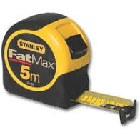
5m tape measure

The easiest way to measure longer distances is to use a measuring wheel. These are inexpensive online or may be borrowed to save cost. The most cost effective way to approximately measure a finite distances however is to pace the distance having calibrated your pace relative to a unit of distance, as described below.

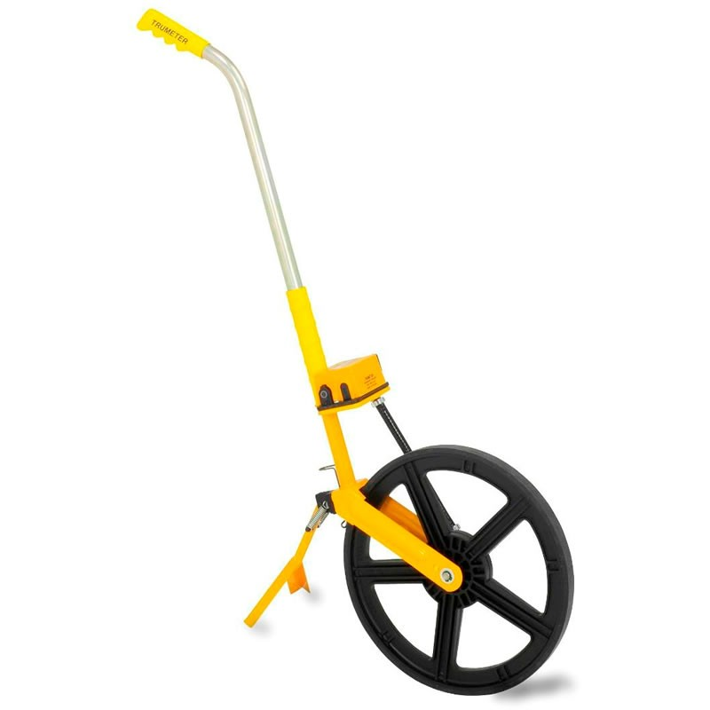

Measuring Wheel

- Distance: Pacing Calculation
Step 1: Measure and mark out 15m on the ground.
Step 2: Starting with your feet behind the zero point, walk your normal natural pace along the line, counting at every second step. Include an approximate measurement of the distance left over at the end of your pacing expressed as a fraction of your two steps.
Step 3: Divide 15m by the number counted

Example:
You have counted to 20 (counting every second step)
15m / no of paces = your pace in meters
15m/20 = 0.75m

You now know your full two-step pace measures 0.75 meters so you can take approximate measurements using your pace as a unit of measurement.

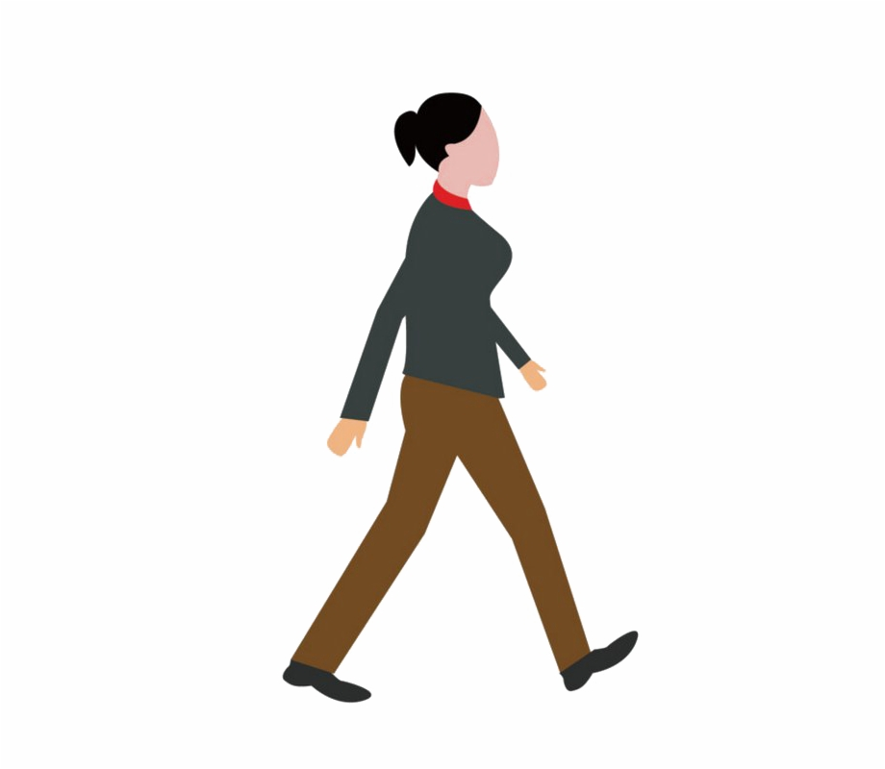
__________________
15m

For longer distances over a trail, it can be useful to record the distance using a trails app, there are many available.

Assessing surface suitability
If you dig your heal into the ground surface and shuffle it you can approximate surface accessibility. If the surface is firm and your heel makes no impact, it should be accessible generally for walking and wheelchairs. If a fine top layer of grit is displaced but the surface is firm under, this would be suitable for a challenging access route. If your heel digs in more and the surfacing builds up around it, this is less accessible and not suitable as either a multi or challenging access route. Note: Design and specification of routes should be undertkaen by professionals who will specify suitable substrates for the design loading

Measuring slope
Ascertaining slope is important for grading the accessibility of a trail. Slope is measured using an inclinometer. You can purchase manual and digital inclinometers but the easiest way to measure slope is using a mobile phone application where you set the phone along a 600mm long batten placed on the ground.
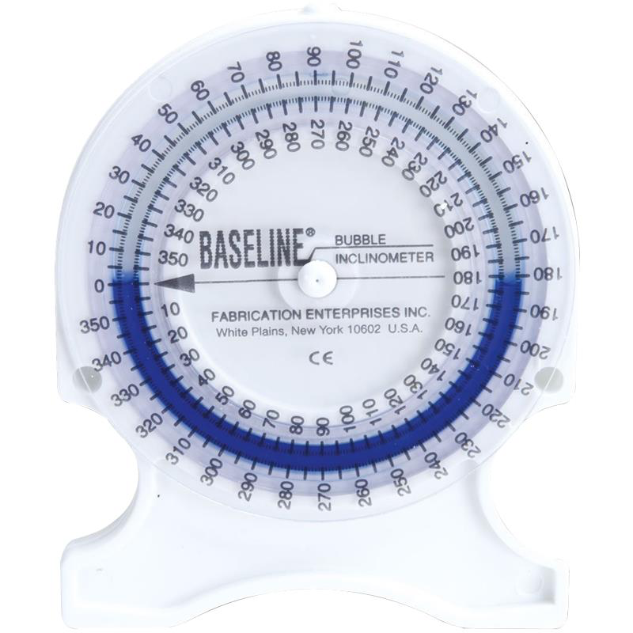

Portable Inclinometer

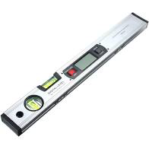

Digital Inclinometer

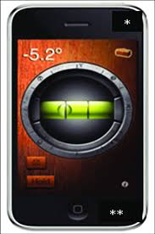

iHandy level app or similar

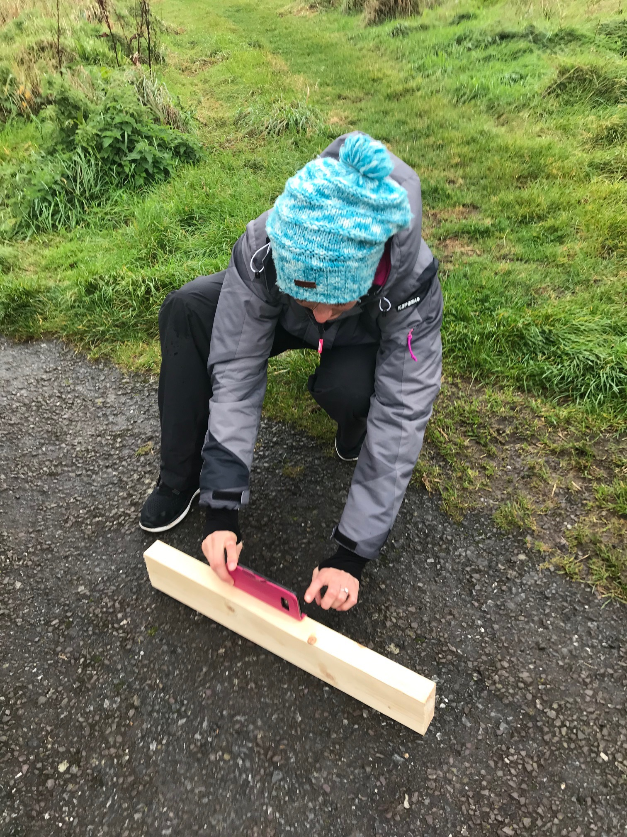

Using a smart phone app

Units of slope explained:
Slope measures the vertical rise over a distance and is normally expressed as a percentage
Eg: The ground rose 4m over a 100m distance

Rise/distance x 100/1

4/100 x 100/1 = 4%

Slope can also be expressed as a as a ratio. 4/100 = 1/25 so the slope is 1 in 25. It is useful to understand how to convert degrees to a percentage or ratio.

1. Degrees Example IF a slope measures 2.3 degrees
Tan 2.3 = 0.04
1/0.04 = 25
y=25

2. Ratio 1 in y 1 in 25

3. Percentage: 100 = % 4%
25

Measuring resistance (physical effort)
It is useful to know the resistance of push / pull effort required at any door / gate along a public access route . Best practice calls for a closing resistance of not more than 20N. (Note: Fire door closing devises are subject to compliance with Building Regulations. If a device cannot fulfill access and fire requirements, an alternate means of door operation should be considered. Refer Building Regulation Technical Guidance Document Part M)

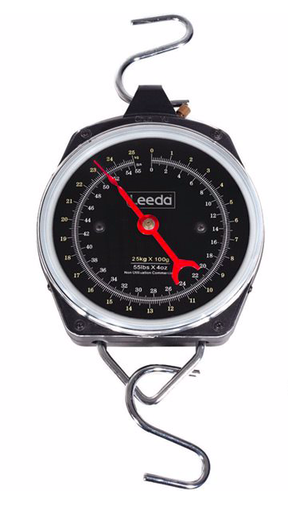

Fish Scale

Turning circles
1500mm and 1800mm wheelchair turning circles are referred to in the guidance. It is useful to have a way of quickly checking these. A foldable disc of light canvas or plastic of the required dimensions can be placed on the ground / floor to this end. It is important to note that objects above floor level (wash hand basins etc) must not encroach on the required area.

Diagram of circle with 1800mm diameter dimension across it and smaller circle inside with 1500mm diameter dimension across it.

Recording
As you are auditing, record all critical information relating it to key points on your map if necessary. Take plenty of photos as a record of your audit. If you have a smart phone, it may be useful to use a trails app to record your journey and also to upload photos at the relevant locations on your journey as you go. A plan and elevation profile will often be generated which is useful for describing the route to others.

