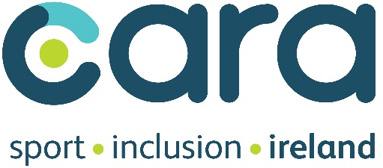
Please affix here your passport-sized photograph

Application for Employment

Post Applied For: | Sport Inclusion Coordinator
Closing Date for Applications is: | Thursday 21st of February 2019 @12noon
Interviews scheduled to take place the week of: | 4th of March 2019

Please complete ALL sections fully. CVs will not be accepted.

Part A
Contact Details
Surname:
First Name(s):
Email Address:
Phone Number:
Postal Address:

Postcode:

Part B

Education

- General Education

Name of school attended | From | To | Certificates and Distinctions obtained

- Further Education
Academic, Professional, or Trade Qualifications

Course studied  (Please state full name of course) | College attended | From | To | Qualification Level  (Please indicate by level only, e.g. 7 or 8) | Please state the awarding body and the full title of the qualification obtained | Grade obtained  (e.g. 2.1, Pass, Credit, Distinction)

Employment Record
- Employment History (please start with most recent position)
* P – Permanent; T – Temporary; A – Acting in post.
When the status is not clearly given, it will be assumed that the position held is a temporary one.

Job Title | From  mm/yy | To  mm/yy | *P/T/A | Name and address of employer
*Most Recent Position

Salary
Reason for leaving
Duties and Responsibilities

Job Title | From  mm/yy | To  mm/yy | *P/T/A | Name and address of employer
Reason for leaving
Duties and Responsibilities

Job Title | From  mm/yy | To  mm/yy | *P/T/A | Name and address of employer
Reason for leaving
Duties and Responsibilities

Job Title | From  mm/yy | To  mm/yy | *P/T/A | Name and address of employer
Reason for leaving
Duties and Responsibilities

Please continue on a separate sheet if necessary.

- List relevant courses/seminars completed/attended
Course/Seminar | Dates/Duration | Certification (if any)

- References
Current/last employee/college

Name | Position held within organisation | Address/Department | Phone Number and Email

Other Referee
Name | Position held within organisation | Address/Department | Phone Number and Email

- Competency Section
You should ensure that the details you provide below clearly demonstrates your ability in carrying out the identified roles and responsibilities of the Sport Inclusion Coordinator.
Please limit your answer to 200-300 words.

Please use this section to let us know why you are interested in this post, what skills and experience you have and how you meet the criteria outlined within the job specification.

- Other Relevant Information
Please note that skills and experience acquired outside of work can SOMETIMES be just as relevant as those gained in work.

Data Protection
The information provided within this application form about you, or third parties (such as referees) will be used solely by Cara in this recruitment process. All personal information provided on this application form will be stored securely in compliance with the Data Protection Act and will be used only for the purposes of the recruitment process. Application forms will be retained for a period of 6 months, and in the case of a successful candidate, for the duration of employment and a minimum of one year thereafter. Internally, the information may be made available to the relevant Line Manager and to the Shortlisting/Interviewing Panel.

I give consent to Cara to process and store my information accordingly

Declaration and Signature:

I understand and agree to the following:
- Canvassing will result in immediate disqualification.
- The post will be subject to Garda Vetting and a 6 month probationary period.
- The employer reserves the right only to interview on the basis of information supplied in the application form by candidates who meet the criteria for the post.
- Cara is an equal opportunities employer, committed to ensuring that the talents and resources of all our employees are utilised to the full. We will not discriminate unfairly against any individual in matters of recruitment or selection for any position, promotion, training or development.
- I declare to the best of my knowledge and belief, all particulars I have given are complete and true. I understand that any false declaration, misleading statement or significant omission may disqualify me from employment and render me liable to dismissal. I understand that any job offer is subject to satisfactory references, sight of educational awards relied upon in this application or at interview and successful completion of a probationary period.

Signature: Date:

___________________________ ___________________

Please submit your application form electronically to Niamh Daffy (CEO, Cara) at ndaffy@caracentre.ie no later than Thursday 21st of February at 12noon.

