Accessibility Statement

Active Disability Ireland is committed to making its website accessible, in accordance with European Union (Accessibility of Websites and Mobile Applications of Public Sector Bodies) Regulations 2020.
This accessibility statement applies to www.activedisability.ie

Compliance Status
This website is partially compliant with Web Content Accessibility Guidelines 2.1 level AA.
Active Disability Ireland is committed to providing a website that is accessible to the widest possible audience, regardless of technology or ability. We are currently working with Vially and Vision Ireland to ensure we meet accessibility standards. We are continually improving the user experience for everyone and adhering to the required accessibility standards.
The Web Content Accessibility Guidelines (WCAG 2.1) defines requirements for designers and developers to improve accessibility for people with disabilities.
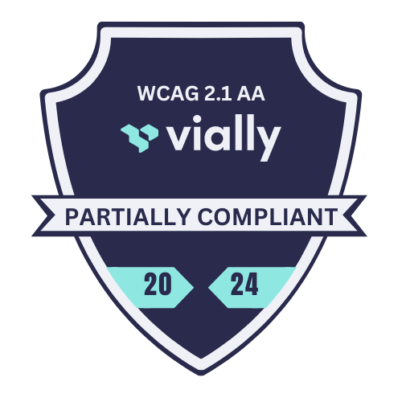

Accessibility Features of this Website
Accessible forms – have correct focus order and validation.
Useful, descriptive link text – to inform users where links will bring them.
Correctly structured content with good heading usage – to increase readability and assist users using screen readers or other assistive technologies.
Cross operating system compatibility and mobile navigation – to ensure consistency in layout and navigation across all devices and operating systems.

Non-accessible Content
Keyboard/Screen reader navigation is not yet accessible on parts of the website.
Skip to content link is not yet fully implemented.
Images – we are currently working through images to add contextual alternative text.
Tables – we are working to create correctly labelled and accessible tables.
Videos – we are working to add captions and text transcripts to videos.
Document accessibility has not yet been implemented.
Third-party content – there are areas of our website controlled by third-party companies, such as cookie settings and the accessibility tools. These are not funded by, developed, or controlled by Active Disability Ireland, but work is in progress to resolve as many issues related to these areas as feasibly possible.

Preparation of this Accessibility Statement
The Statement was prepared by Vially where Vially performed a blend of manual and automated accessibility tests using multiple platforms Windows (JAWS, NVDA), Mac (VoiceOver), iOS (VoiceOver) and Android (TalkBack) and their native accessibility tools. A detailed issue log was created to measure against WCAG 2.1 standards. These issues were presented to the development team who are amending these issues and bringing the website in to WCAG 2.1 AA compliance.
This statement was created by Vially in June 2024.
The statement was last reviewed in June 2024 and will be reviewed on an ongoing basis and formally every 12 months.

Feedback and Contact Information
We welcome feedback on the accessibility of this website. If you have any comments or find any problems not listed on this page, please contact info@activedisability.ie

Enforcement Procedure
If you are not happy with our response or if you want to raise an accessibility issue that is not related to this website, you can ask the Ombudsman to look into it. Contact the office of the Ombudsman or read guidance on how to make a complaint.

WCAG 2.1 Accessibility Auditing Service
If you would like your website, application or digital documents reviewed and tested against the WCAG 2.1 standards, please contact the Vially team at hello@vially.io.

